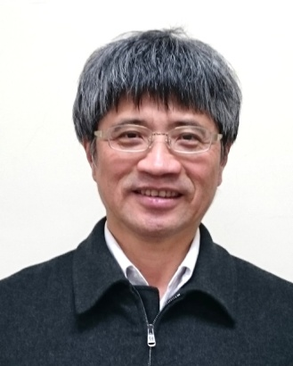
LIU, Jann-Yenq (Tiger) is a Chair Professor at National Central University, Taiwan. His research specialty is ionospheric physics. He received BS, Atmospheric Physics Department, National Central University, TAIWAN in 1980, as well as MS and PhD, Physics Department, Utah State University, USA in 1988 and 1990, respectively. He was Associated Professor at Graduate Institute of Space Science, as well as Center for Space and Remote Sensing Research, National Central University, TAIWAN during 1990-1997, and has been Professor since 1997. He also served as Chief Scientist of National Space Organization (NSPO) in Taiwan during 2011-2015. He becomes a Director of Center for Astronautical Physics and Engineering (CAPE), National Central University since 2018. His research areas are in ionospheric space weather (solar flare, solar eclipse, and magnetic storm signatures), ionospheric data assimilation, ionospheric radar science, space-based (radio occultation, RO) and ground-based GNSS geosciences applications (ionospheric total electron content, TEC), ionospheric plasma in situ probing, seismo-traveling ionospheric disturbance (ionospheric seismic and tsunami wave signatures), and seismo-ionospheric precursors. He has been publishing more than 270 referred journal papers since 1988. He is the member of AGU, EGU, AOGS, CGU, and JpGU.

